CHAPTER – 1 : INTRODUCTION

In an increasingly connected world, the integration of physical devices with the internet, commonly known as the Internet of Things (IoT), offers unprecedented opportunities to enhance safety, efficiency, and convenience across various domains. One critical area where IoT can make a significant impact is in fire detection and prevention.

Traditional fire alarm systems often rely on localized audible alerts, which may not be sufficient for comprehensive and timely warnings, especially when occupants are not present or in large, complex environments. The advent of affordable and powerful microcontrollers with integrated Wi-Fi capabilities, such as the ESP8266, has opened new avenues for developing smart, interconnected fire detection systems that can provide remote monitoring and instant alerts.

This project aims to leverage these advancements to create a robust and intelligent fire detection system that goes beyond conventional methods, offering real-time data monitoring and immediate notification capabilities to users. The objective is to design and implement a system that can accurately detect the presence of fire and smoke, communicate this information seamlessly over the internet, and alert stakeholders through various channels, thereby minimizing potential damage and ensuring the safety of lives and property.

  - Problem Statement

Fire poses a significant threat to life and property worldwide, causing substantial economic losses and, tragically, fatalities. Conventional fire detection systems, while essential, often have limitations:
- These systems typically rely on smoke detectors and heat sensors that trigger local alarms, which may not be effective in alerting individuals who are not within audible range or are away from the premises.
- In many cases, by the time a fire is detected and responded to, significant damage may have already occurred. There is a pressing need for a more advanced, proactive fire detection system that can provide immediate and remote alerts, allowing for quicker response times and better mitigation of fire-related risks.

- Existing solutions sometimes lack integration with modern communication channels like email or real-time cloud monitoring, limiting their effectiveness in a truly connected environment.

- Furthermore, the complexity and cost associated with implementing comprehensive smart home solutions often deter widespread adoption.
This project addresses these challenges by developing an affordable, efficient, and user-friendly IoT-based fire detection system that integrates sensor data with cloud services and email alerts, thereby bridging the gap between localized detection and remote notification.

1.2 Objectives

The overarching objective of this project is to design, develop, and implement an IoT-based fire detection system that provides real-time monitoring and immediate alerts to users. This system aims to enhance safety by detecting fire and smoke conditions promptly and ensuring timely communication with relevant individuals.

1.2.1 Specific Objectives
- To integrate a Flame Sensor and an MQ-02 Smoke Sensor with an ESP8266 microcontroller to accurately detect the presence of flames and smoke respectively. The system will interpret the digital output of the Flame Sensor (LOW for fire detection) and the analog output of the MQ-02 Smoke Sensor (0-1023 for smoke intensity).

- To implement a voltage divider circuit to safely interface the 5V operating voltage of the sensors with the 3.3V operating voltage of the ESP8266, preventing damage to the microcontroller.
- To program the ESP8266 microcontroller using the Arduino IDE to read sensor data, process it to determine fire conditions, and initiate alerting procedures.
- To establish communication between the ESP8266 and an SMTP server for sending automated email alerts to predefined recipients when a fire or smoke threshold is exceeded. This includes utilizing the SMTPSession and SMTP_Message classes for managing email transmission and handling callback functions for status updates.
- To integrate the system with the ThingSpeak IoT cloud service to display real-time sensor data, such as smoke intensity and flame detection status, to the user through a web-based interface.
- To design and develop a single-sided Printed Circuit Board (PCB) for the system, ensuring proper component placement and efficient electrical connections.
- To ensure the security of user credentials by using an App Password for Gmail and preventing its direct exposure within the code.

1.3 Research Methodology

The research methodology involved a systematic approach.
- Beginning with a comprehensive literature review to understand existing fire detection technologies and IoT platforms.
- This informed the selection of the ESP8266 NodeMCU microcontroller for its integrated Wi-Fi and Arduino IDE compatibility, along with Flame and MQ-02 Smoke Sensors.
- Circuit design focused on safely interfacing the 5V sensors with the 3.3V ESP8266 using a potential divider circuit, which was crucial to prevent microcontroller damage.

- Software development, using the Arduino IDE, involved programming the ESP8266 to read sensor data and determine fire conditions based on thresholds.
- The project heavily utilized the SMTP protocol for sending email alerts, employing SMTPSession and SMTP_Message classes, and integrating a smtpCallback function for status monitoring.
- Data was also sent to ThingSpeak for real-time visualization.
- Security practices, such as using an App Password for Gmail, were emphasized to protect credentials.
- Rigorous testing validated component functionality, Wi-Fi connectivity, and the email alert system.
- Finally, a custom single-sided PCB was designed using Eagle CAD and fabricated through a multi-step process including etching and drilling.
  - Project Scope
The scope of this project is precisely defined to ensure achievable outcomes within the given resources and timeline. The project encompasses:

- Hardware Design and Integration: This includes the selection and integration of the NodeMCU ESP8266 microcontroller with a Flame Sensor and an MQ-02 Smoke Sensor. It also covers the design and implementation of a voltage divider circuit to ensure proper voltage compatibility between the sensors and the microcontroller.

- Firmware Development: Developing the code for the ESP8266 using the Arduino IDE to read and process sensor data, determine fire conditions based on predefined thresholds, and initiate alerts.

- Email Alerting System: Implementing the functionality to send automated email alerts to predefined recipients via an SMTP server when fire or smoke is detected. This involves configuring SMTP parameters, using SMTPSession and SMTP_Message classes, and handling callback functions for delivery status.
- Real-time Data Monitoring: Integrating the system with ThingSpeak, an IoT cloud platform, to allow users to view real-time sensor data through a web interface.
- Security for Credentials: Implementing and recommending the use of an App Password for Gmail to secure email credentials and prevent their exposure in the codebase.

- PCB Design and Fabrication: Designing a custom single-sided Printed Circuit Board (PCB) using Eagle CAD and fabricating it, including steps like copper clad board preparation, etching, drilling, and cleaning.

- Basic Alert Logic: The system will send an alert when the smoke sensor value exceeds a threshold, and then reset the alert status when the value falls below the threshold.

1.5 Out of Scope

To maintain focus and ensure project feasibility, the following aspects are considered out of scope for this particular project:
- Development of a dedicated mobile application or website: While mentioned as a potential upgrade, the project will not involve the development of a custom mobile app or full-fledged website for user interaction beyond the ThingSpeak web interface.
- Battery Power Supply and Charging Module: The project will not incorporate a battery-based power supply or a charging module. The system will be powered directly via USB.
- Multi-sensor Redundancy and Advanced Fault Tolerance: While the system uses two sensors, it will not implement complex redundancy or advanced fault-tolerance mechanisms to handle sensor failures or network outages beyond basic error handling for SMTP communication.

- Integration with home automation systems: The project focuses solely on fire detection and alerting and will not be integrated with existing smart home automation platforms for controlling other devices.

CHAPTER – 2 : METHODOLOGY
The development of the IoT-based fire detection system involved a meticulously planned methodology, integrating various hardware components, software tools, and algorithmic techniques. Each choice was made with a clear rationale to ensure the system's efficiency, accuracy, and reliability. This section details the specific methods and tools employed throughout the project lifecycle.

2.1 Hardware Components and Integration
The selection of hardware components was driven by the need for cost-effectiveness, readily available resources, and specific functionalities essential for fire detection and IoT connectivity.

2.1.1 NodeMCU ESP8266 Module
- Description: The NodeMCU ESP8266 WiFi Module serves as the central microcontroller for this project.
- Rationale:
  - It possesses an inbuilt WiFi module, eliminating the need for an external module like ESP01, which would increase circuit area.
  - It supports programming using the Arduino IDE, simplifying the development process.
  - It operates at 3.3V and supports TCP/IP networking, GPIO, PWM, and ADC functionalities.
  - It is particularly useful for IoT-based and home automation systems.

2.1.2 Flame Sensor
- Description: This device is used to detect the presence of a flame.
- Rationale: Its direct detection of flames provides an immediate indication of a potential fire, crucial for early warning systems.
- Functionality:
  - Operates at 5V.
  - Uses an IR sensor to detect fire.
  - Provides a "LOW" output at its digital pin when fire is detected.

2.1.3 MQ-02 Smoke Sensor
- Description: This device is used to detect the presence of smoke.
- Rationale: Its analog output allows for nuanced measurement of smoke levels, enabling differentiation between minor smoke occurrences and significant fire events. This quantitative data is essential for setting thresholds.
- Functionality:
  - Operates at 5V.
  - Uses its "ANALOG OUT" PIN to check the amount of smoke detected.
  - Intensity is represented by numbers ranging from 0 to 1023 (10-bit sensor).

2.1.4 Potential Divider Circuit
- Rationale:
  - The ESP8266 only supports 3.3V (+/-0.1), and feeding it higher voltage would harm the controller.
  - Both the Flame sensor and MQ02 sensor work at 5V and thus would output 0V or 5V (Flame sensor) or 0 to 5V (MQ02 sensor), which is not suitable for the ESP8266.
  - To avoid this problem, a potential divider circuit is used.
- Implementation:
  - The output from both sensors is fed to a series system of 1k and 2k resistors.
  - By the potential divider concept, the voltage drop at the 2k resistor due to the flame sensor is fed to the D0 pin of the ESP8266 board.
  - Similarly, the voltage drop at the 2k resistor due to the MQ02 sensor is fed to the A0 pin of the ESP8266 board.
  - This results in a voltage of approximately 3.33V, which is the safe operating voltage for the ESP8266.

2.2 Software Development and Algorithms
The software component is responsible for reading sensor data, processing it, making decisions about fire detection, and initiating alerts. The Arduino IDE served as the primary development environment.

2.2.1 Arduino IDE and ESP8266 Programming
- Description: The Arduino IDE is used for programming the ESP8266.
- Rationale: Its widespread adoption, extensive libraries, and ease of use, coupled with ESP8266 compatibility, accelerate the development cycle.
- Functionality: The code reads the digital output from the Flame Sensor and the analog output from the MQ-02 Smoke Sensor.

2.2.2 Fire Detection Algorithm
- Purpose: To determine if a fire has started based on sensor readings.
- Logic:
  - Flame Sensor: When the flame sensor detects a flame, it goes "LOW".
  - MQ-02 Smoke Sensor: The analog output value (0-1023) from the MQ-02 sensor is continuously monitored.
  - Thresholding: A predefined threshold value is set for the smoke sensor.
  - Alert Triggering:
    - bool alertSent = false;: A boolean variable alertSent is initialized to false to track if an alert has already been sent.
    - Rationale for bool: Using bool makes the code more readable and self-explanatory, clearly indicating a YES/NO condition for alert status, improving code readability compared to using 0 or 1.
    - if (value > threshold) { sendAlertEmails("Sensor exceeded threshold! Value: " + String(value)); alertSent = true; }: If the MQ02 sensor value exceeds the threshold and an alert has not been sent (alertSent is false), an email alert is sent, and alertSent is set to true. This prevents multiple alerts for the same continuous event.
    - if (value <= threshold) { alertSent = false; }: If the sensor value falls below or equals the threshold, alertSent is reset to false, allowing for future alerts if the threshold is crossed again.

2.2.3 Email Alerting Mechanism (SMTP)
The system utilizes the Simple Mail Transfer Protocol (SMTP) for sending email alerts, providing a reliable and widely accessible notification method.
- SMTP Definition: SMTP (Simple Mail Transfer Protocol) is the standard protocol used by email servers to send emails.
- SMTPSession Class:
  - Description: SMTPSession is a class or data type that handles the creation and management of an SMTP session.
  - Functionality: It includes functions for connecting to an SMTP server, sending emails, handling communication protocols related to email transmission, and ending connections.
  - Usage: An smtp variable from the SMTPSession class is used for managing these tasks in the program.
- Callback Function (smtpCallback):
  - Description: void smtpCallback(SMTP_Status status) defines a function that takes an SMTP_Status object as a parameter, containing information about the SMTP session status (e.g., success, failure, error).
  - Purpose: It allows defining a callback function that will be called when certain events (like sending an email) occur.
  - Functionality:
    - Serial.println(status.info());: This line prints the status information to the Serial Monitor.
    - status.info() is a method that returns a string with descriptive information about the SMTP session's current state (e.g., "Connection successful," "Email sent," "Error 500: Server unavailable").
    - Serial.println() prints this string to the Serial Monitor, allowing real-time monitoring and debugging of the email sending process.
  - Rationale: The callback function is crucial for logging and monitoring the email sending process, aiding in debugging and understanding whether the email sending was successful or encountered errors.
- SMTP_Message Class:
  - Description: SMTP_Message is a class or data type that holds the structure and details of an email message, including sender, recipient, subject, and content.
  - Usage: A message variable stores the email content.
  - Functionality:
    - message.addRecipient("User", email);: This method adds the recipient's email address to the "To" section, using a name and the email address as parameters.
    - message.text.charSet = "utf-8";: Sets the character set for the email text to UTF-8, supporting a broad range of characters, including special symbols and non-English characters.
    - message.text.transfer_encoding = Content_Transfer_Encoding::enc_7bit;: Specifies 7-bit encoding for the email body, which is common for plain text emails, ensuring the message is sent without special characters or binary data.
- Email Sending:
  - if (!MailClient.sendMail(&smtp, &message)): This function attempts to send the email using the smtp session object and the message object. If the sending fails, the if condition becomes true.
  - smtp.closeSession();: After sending the email, the SMTP session is closed to free up resources and terminate the connection to the SMTP server, preventing resource leaks.

2.2.4 Security for Email Credentials
- Method: The project emphasizes generating and using an "App Password" for Gmail instead of the main account password.
- Rationale:
  - To prevent exposure of sensitive credentials: If the .ino file containing the code falls into the wrong hands or is posted online (e.g., GitHub), the Gmail and app password could be compromised.
  - It is safer to separate credentials and keep them private.
- Steps to Generate App Password:
  - Go to: https://myaccount.google.com/apppasswords.
  - Sign in and choose "Mail" as the app and "Other" (or "ESP8266") as the device.
  - Generate and copy the 16-digit password.
  - Replace "your_app_password" with this 16-digit password in the code.

2.2.5 SSL/TLS for Secure Communication
- Description: SSL (Secure Sockets Layer) and TLS (Transport Layer Security) are cryptographic protocols that provide secure communication over a computer network.
- Rationale: To ensure that sensitive information (like passwords) remains private and to encrypt data and authenticate parties involved, guaranteeing data integrity and privacy.
- Functionality:
  - SSL is an older protocol used to encrypt data transferred between a client (e.g., web browser) and server.
  - TLS is the successor to SSL, offering more robust security and is widely used today.
  - Even though SSL is deprecated, the term "SSL" is often still used to refer to TLS-based protocols (e.g., SMTPS on port 465). SMTP over SSL typically uses Port 465.

2.3 Cloud Integration (ThingSpeak)
- Purpose: To display real-time data to the user.
- Description: ThingSpeak is an IoT-based cloud service that allows for the visualization of real-time data.
- Rationale: It provides a convenient and accessible platform for users to monitor sensor readings (e.g., smoke levels) remotely through a web interface, using gauges and charts.
- Functionality: The ESP8266 sends the collected sensor data to the ThingSpeak platform, where it can be viewed and analyzed by the user.

2.4 PCB Design and Manufacturing Process
The creation of a custom Printed Circuit Board (PCB) was an integral part of transforming the prototype into a more compact and durable system.

2.4.1 Type of PCB
- Choice: A single-sided (bottom-sided) PCB was chosen.
- Rationale: This type of PCB is sufficient due to the simplicity of the circuit.

2.4.2 Designing Schematic (Eagle CAD)
- Tool: Eagle CAD, a PCB designing tool, was used to design the schematic.
- Purpose: To create a detailed layout of the circuit connections and component placement.

2.4.3 PCB Manufacturing Steps
- Step 1: Copper Clad Boards: The base of the PCB is made from a fibre or glass board with a layer of copper on top to provide conduction.
- Step 2: Printing PCB Design: The designed layout from Eagle CAD is printed onto photo paper using a laser printer.
- Step 3: Hotpressing Design on Board: A cloth iron is used to hot-press the printed design onto the copper side of the board, transferring the printed tracks.
- Step 4: Removing Rest of Copper:
  - Rationale: Only the desired conductive tracks (marked in red in the design) are needed.
  - Method: The board is dipped in a solution of FeCl3 (Ferric Chloride). This chemical etches away all the copper that is not protected by the printer ink, leaving only the desired tracks.
- Step 5: Drill Holes: Holes are drilled in the designated pad locations to allow for the insertion and soldering of electronic components.
- Step 6: Remove Ink: Any remaining printer ink on the copper tracks is removed using petrol.
This systematic methodology, encompassing detailed hardware selection, sophisticated software development with robust algorithms, secure cloud integration, and precise PCB manufacturing, ensures the successful realization of an efficient and reliable IoT-based fire detection system.

CHAPTER 3 : CIRCUIT DESIGN
The IoT-based fire detection system is designed with a modular architecture, ensuring clear separation of concerns and efficient data flow between various components. This section provides a detailed overview of the system's architecture, the interaction between its modules, and a placeholder for the integrated circuit diagram.

3.1 System Architecture Overview
The overall system architecture can be conceptualized as a multi-layered structure, encompassing sensing, processing, communication, and notification. At its core, the system relies on physical sensors to detect environmental conditions, which are then processed by a microcontroller. This processed data is subsequently transmitted to cloud platforms and used to trigger alerts, thereby providing a comprehensive solution for fire detection and remote monitoring.
The architecture is primarily divided into the following key layers/modules:
- Sensing Layer: This layer is responsible for gathering raw data from the physical environment. It consists of the Flame Sensor and the MQ-02 Smoke Sensor, which are strategically placed to detect the presence of fire and smoke.
- Processing and Control Layer (Edge Computing): This layer is handled by the ESP8266 NodeMCU module. It acts as the brain of the system, receiving analog and digital inputs from the sensors, performing data interpretation, and executing predefined logic to determine the presence of a fire or significant smoke levels. This layer also manages the Wi-Fi connectivity.
- Communication Layer: This layer facilitates the transmission of processed data and alerts over the internet. It leverages the ESP8266's integrated Wi-Fi module to connect to the local network and subsequently to external servers. Key protocols in this layer include TCP/IP, SMTP for email, and HTTP/MQTT for cloud communication with ThingSpeak.
- Cloud Platform Layer: This layer involves the ThingSpeak IoT cloud service. It acts as a centralized repository for real-time sensor data, providing visualization and logging capabilities.
- Notification Layer: This layer is responsible for alerting the end-users. Primarily, it utilizes an SMTP server to send email notifications based on predefined alert conditions.

3.2 Module Interaction and Data Flow
The modules within the system interact seamlessly to ensure timely detection and notification. The interaction follows a logical flow from sensor data acquisition to user alerts and cloud monitoring.

3.2.1 Sensor Data Acquisition
- Flame Sensor:
  - Input: Detects infrared radiation emitted by flames.
  - Output: Provides a digital "LOW" signal to the ESP8266's D0 pin when a flame is detected.
  - Interaction: The Flame Sensor's output is first routed through the potential divider circuit before reaching the ESP8266.
- MQ-02 Smoke Sensor:
  - Input: Detects smoke and combustible gases.
  - Output: Generates an analog voltage signal (0-5V, converted to 0-1023 by the ESP8266's ADC after voltage division) to the ESP8266's A0 pin, where higher values indicate greater smoke concentration.
  - Interaction: Similar to the Flame Sensor, the MQ-02 Smoke Sensor's analog output passes through the potential divider circuit to reduce its voltage to a safe level for the ESP8266.

3.2.2 Voltage Division and Microcontroller Input
- Potential Divider Circuit:
  - Function: This circuit is critical for safety and compatibility. Both the Flame Sensor and MQ-02 Smoke Sensor operate at 5V, while the ESP8266 operates at 3.3V. Directly connecting the 5V output of the sensors to the ESP8266's input pins would damage the microcontroller.
  - Components: Consists of a 1k Ohm resistor and a 2k Ohm resistor connected in series.
  - Interaction:
    - The output of the Flame Sensor is fed into this series combination. The voltage across the 2k Ohm resistor (approximately 3.33V when the sensor outputs 5V) is then connected to the D0 digital input pin of the ESP8266.
    - The analog output of the MQ-02 Smoke Sensor is also fed into a separate potential divider circuit. The voltage across the 2k Ohm resistor from this setup (approximately 3.33V for a 5V input) is connected to the A0 analog input pin of the ESP8266.
  - Rationale: This ensures that the input voltage to the ESP8266 remains within its safe operating range, preventing damage while still accurately transmitting sensor data.

3.2.3 ESP8266 Processing and Decision Making
- Data Reception: The ESP8266 continuously reads the digital state of its D0 pin (from the Flame Sensor) and the analog value of its A0 pin (from the MQ-02 Smoke Sensor).
- Data Interpretation:
  - For the Flame Sensor, a "LOW" digital reading is interpreted as the presence of a flame.
  - For the MQ-02 Smoke Sensor, the analog value (0-1023) is compared against a predefined threshold.
- Decision Logic: The microcontroller's firmware applies the fire detection algorithm:
  - If the Flame Sensor detects a flame (LOW signal) OR if the MQ-02 Smoke Sensor's analog value exceeds the predefined smoke threshold, the system registers a "fire condition."
  - A boolean flag, alertSent, is managed by the ESP8266. If a fire condition is detected and alertSent is false, an alert is triggered, and alertSent is set to true. This prevents redundant alerts for a continuous event.
  - If the sensor values return to normal (i.e., below the threshold for smoke, or flame not detected), the alertSent flag is reset to false, allowing for new alerts if another fire condition arises.

3.2.4 Internet Communication and Alerting
- Wi-Fi Connectivity: The ESP8266, with its integrated Wi-Fi module, establishes a connection to the local Wi-Fi network (SSID). This connection forms the gateway for all internet-based communication.
- SMTP Communication (Email Alerts):
  - Trigger: When a fire condition is detected (and alertSent is false), the ESP8266 initiates an email sending process.
  - SMTPSession: An instance of the SMTPSession class (smtp) manages the connection to the SMTP server (e.g., Gmail's SMTP server). This includes authentication using the sender's email and a secure App Password.
  - SMTP_Message: An instance of the SMTP_Message class (message) is constructed, containing the recipient's email address, subject line (e.g., "FIRE ALERT!"), and a descriptive body message (e.g., "Smoke sensor exceeded threshold! Value: [current smoke value]").
  - Secure Transmission (SSL/TLS): The email is sent over a secure connection using SSL/TLS (typically via port 465) to ensure data encryption and protect credentials.
  - Callback Function: The smtpCallback function monitors the status of the email sending process, providing real-time feedback to the Serial Monitor (e.g., "Email sent successfully," "Connection failed").
  - Interaction: The ESP8266 acts as an SMTP client, sending commands to the SMTP server to relay the email to the recipient.
- ThingSpeak Integration (Real-time Monitoring):
  - Data Transmission: Concurrently, the ESP8266 also sends the raw or processed sensor data (e.g., MQ-02 smoke sensor value, Flame Sensor status) to the ThingSpeak cloud platform.
  - API Key: The ESP8266 authenticates with ThingSpeak using a unique API write key for the designated channel.
  - Visualization: Once data is received by ThingSpeak, it is displayed on customizable gauges and charts on the ThingSpeak web interface, providing users with real-time visual monitoring of environmental conditions from anywhere with internet access.
  - Interaction: The ESP8266 makes HTTP requests to the ThingSpeak API to update the channel fields with the latest sensor readings.

3.3 System Circuit Diagram
The following section provides a visual representation of the interconnected hardware components, illustrating how each sensor, the potential divider circuit, and the ESP8266 are wired together.
Circuit Diagram: IoT Based Fire Detection System

The circuit diagram visually confirms the connections:
- The 5V VCC and GND of both Flame and MQ-02 sensors are connected to the 5V and GND pins of the ESP8266/power supply.
- The digital output pin of the Flame Sensor is connected to the potential divider, whose output goes to a digital GPIO pin (e.g., D0) on the ESP8266.
- The analog output pin of the MQ-02 Smoke Sensor is connected to its dedicated potential divider, whose output goes to the analog input pin (A0) on the ESP8266.
- The ESP8266 is powered via its micro-USB port or Vin pin.

3.4 Power Management
While the core components of the system (ESP8266, Flame Sensor, MQ-02 Smoke Sensor) typically operate at specific voltage levels (3.3V for ESP8266, 5V for sensors), the overall power management strategy ensures stable and continuous operation.
- ESP8266 Power: The NodeMCU ESP8266 module is usually powered via its micro-USB port, which can be connected to a computer, a 5V USB adapter, or a power
bank. The module itself has an onboard voltage regulator that steps down the input voltage to 3.3V for the ESP8266 chip.
- Sensor Power: The Flame Sensor and MQ-02 Smoke Sensor are designed to operate at 5V. In the prototype phase, these would typically draw power directly from the 5V pin of the ESP8266 (if available and sufficient current capacity) or an external 5V power supply.
- Voltage Consistency: The crucial point of power management, as detailed in the "Potential Divider Circuit" section, is the voltage reduction for sensor outputs before they reach the ESP8266's input pins. This is not about powering the sensors but about ensuring the signal voltage is safe for the ESP8266's inputs. The sensors themselves still require their 5V operating voltage.
- PCB Integration: On the final PCB, dedicated power traces would distribute the 5V and 3.3V (generated onboard if needed) to the respective components, ensuring clean power delivery and minimizing noise. Proper decoupling capacitors would also be included near ICs to stabilize power rails.

3.5 Reliability and Redundancy Considerations
While a basic fire detection system, certain design choices contribute to its reliability, and potential areas for future redundancy can be identified.
- Dual Sensor Approach: The use of both a Flame Sensor and a Smoke Sensor provides a level of redundancy in detection. If one sensor is less effective in a particular fire scenario (e.g., a smoky fire with little flame, or a sudden flame with minimal initial smoke), the other sensor can still trigger an alert. This improves the overall reliability of fire detection compared to a single-sensor system.
- Boolean Alert Tracking: The alertSent boolean flag helps prevent excessive and redundant email alerts during a prolonged fire event. Once an alert is sent, further emails are suppressed until the fire condition subsides and then reappears, ensuring that users receive actionable, rather than spammy, notifications.
- Callback for SMTP Status: The smtpCallback function is a crucial debugging and reliability feature. By providing real-time feedback on the email sending process, it allows for quick identification of issues (e.g., network problems, incorrect credentials, server errors) that might prevent alerts from being sent. This enhances the system's maintainability.
- Secure Email Transmission: The use of SSL/TLS for SMTP communication ensures that email alerts are transmitted securely. This protects the content of the alerts and prevents sensitive login credentials from being intercepted, contributing to the overall security and trustworthiness of the system.
- Cloud Logging: ThingSpeak provides a continuous log of sensor data. Even if email alerts fail for some reason, the historical data on ThingSpeak can still provide valuable insights into the event, acting as a secondary record and a form of data redundancy.
While the current design is robust for its stated scope, future enhancements could involve:
- Network Redundancy: Implementing a fallback communication method (e.g., cellular module) if Wi-Fi connectivity is lost.
- Sensor Redundancy: Adding multiple instances of each sensor type to average readings and provide better fault tolerance against individual sensor failure.
- Power Redundancy: Integrating a battery backup system to ensure continuous operation during power outages.
These considerations demonstrate a thoughtful approach to system design, prioritizing both immediate functionality and future scalability for enhanced reliability.

CHAPTER 4 : IMPLEMENTATION
The implementation phase of the IoT-based fire detection system involved translating the theoretical design into a functional prototype, encompassing hardware assembly, software development, and integration of cloud services. This phase presented several challenges, alongside the successful implementation of key functions and modules that define the system's capabilities.

4.1 Challenges Faced During Implementation
Implementing an IoT system, especially one involving physical sensors and cloud communication, inherently comes with a set of challenges. Addressing these effectively was crucial for the project's success.

4.1.1 Voltage Mismatch Between Sensors and ESP8266
- Challenge: The Flame Sensor and MQ-02 Smoke Sensor operate at 5V, while the ESP8266 microcontroller operates at a maximum of 3.3V. Direct connection of the 5V output from the sensors to the ESP8266's input pins would result in overvoltage, potentially damaging or destroying the microcontroller's sensitive GPIO or ADC pins.
- Resolution: This critical issue was resolved by implementing a potential divider circuit for each sensor's output. By using a series combination of 1k Ohm and 2k Ohm resistors, the 5V sensor output was safely stepped down to approximately 3.33V, which is within the permissible input voltage range for the ESP8266's D0 (digital) and A0 (analog) pins. This ensured compatibility and prevented hardware failure.
- Rationale: This was a fundamental design consideration to ensure the longevity and stable operation of the ESP8266, which is the brain of the system.

4.1.2 Reliable Wi-Fi Connectivity and Stability
- Challenge: Ensuring stable and consistent Wi-Fi connectivity for the ESP8266 was vital for continuous data transmission to ThingSpeak and timely email alerts. Environmental factors, network congestion, and Wi-Fi signal strength could lead to intermittent connections or disconnections, impacting the system's reliability.
- Resolution:
  - Strategic Placement: During testing, the physical placement of the ESP8266 and its distance from the Wi-Fi router were optimized to ensure strong signal reception.
  - Robust Reconnection Logic: The firmware was programmed with robust Wi-Fi reconnection logic. If the ESP8266 loses connection, it continuously attempts to re-establish it, preventing prolonged downtime.
  - Serial Monitor Debugging: The Arduino IDE's Serial Monitor was extensively used to track Wi-Fi connection status, providing real-time feedback on connection attempts, successes, and failures, which aided in troubleshooting.
- Rationale: Without a stable internet connection, the core IoT functionalities of remote monitoring and email alerting would be compromised.

4.1.3 Secure Handling of Email Credentials (SMTP)
- Challenge: Directly embedding the main Gmail account password in the code is a significant security risk. If the code is shared or exposed, the account credentials could be compromised, leading to unauthorized access.
- Resolution: The project explicitly adopted the use of Google's App Passwords. An App Password is a 16-digit passcode that grants an app or device permission to access your Google Account, instead of your primary password. This password is then used in the ESP8266's SMTP configuration.
- Rationale: This method drastically reduces the security risk. Even if the App Password in the code is exposed, it only grants limited access (e.g., sending emails) and cannot be used to log into the main Google account directly. It also encourages best practices for credential management in IoT applications.

4.1.4 Debugging Asynchronous SMTP Communication
- Challenge: SMTP communication can be asynchronous, meaning that sending an email is not an instantaneous, blocking operation. Understanding the status of the email (sent, failed, network error) in real-time can be difficult without proper feedback mechanisms.
- Resolution: The implementation of a callback function (smtpCallback) was crucial. This function is triggered by the SMTP client library (MailClient) during various stages of the email sending process, providing status updates.
- Rationale: The smtpCallback function prints detailed information about the SMTP session status to the Serial Monitor. This provides invaluable debugging information, allowing developers to quickly identify whether an email failed due to network issues, server errors, or incorrect credentials, significantly speeding up the troubleshooting process.

4.1.5 Analog Sensor Reading and Thresholding
- Challenge: Interpreting the analog output of the MQ-02 Smoke Sensor (0-1023) and setting an appropriate threshold for fire detection required careful calibration. The ambient smoke levels can vary, and a fixed threshold might lead to false positives or missed detections.
- Resolution:
  - Empirical Calibration: The smoke sensor was calibrated empirically by observing its analog output under various conditions (normal ambient air, presence of mild smoke, presence of significant smoke).
  - Adjustable Threshold: The threshold value was defined as a variable in the code, allowing for easy adjustment and fine-tuning based on deployment environment and desired sensitivity.

  - Continuous Monitoring: ThingSpeak was used to continuously monitor the smoke sensor's readings in real-time, helping to visually identify typical ambient levels and suitable alert thresholds.
- Rationale: Accurate thresholding is fundamental to the system's effectiveness, minimizing both false alarms and missed fire events.

4.2 Key Functions and Modules Implemented
The system's functionality is built upon several key software functions and hardware modules that interact to achieve the project's objectives.

4.2.1 Sensor Reading and Processing Module
- Purpose: To acquire raw data from the Flame and MQ-02 Smoke sensors and translate it into actionable information.
- Key Functions:
  - analogRead(A0): Reads the analog value from the MQ-02 Smoke Sensor connected to pin A0 of the ESP8266. This returns an integer between 0 and 1023.
  - digitalRead(D0): Reads the digital state of the Flame Sensor connected to pin D0. Returns HIGH or LOW.
  - setup() function: Initializes serial communication, Wi-Fi connection, and sets up sensor pins.
  - loop() function: The main program loop that continuously reads sensor data, applies detection logic, and triggers actions.
- Code Snippet: Sensor Reading Logic
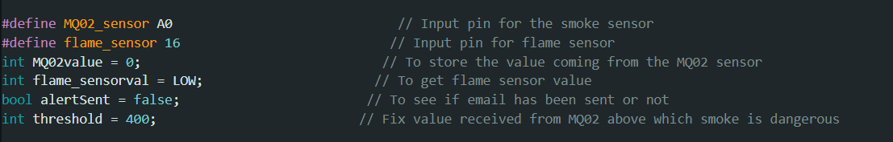
- Explanation: This snippet shows the core reading operations. The analogRead function directly provides the 10-bit value from the MQ-02 after its voltage has been safely reduced by the potential divider. The digitalRead for the flame sensor similarly reads the "LOW" or "HIGH" state.

4.2.2 Fire Detection and Alert Logic Module
- Purpose: To determine if a fire condition exists based on sensor data and manage the alert sending process.
- Key Variables/Functions:
  - threshold: A predefined integer value against which the smoke sensor reading is compared.
  - bool alertSent: A boolean flag (initialized to false) to prevent sending multiple duplicate alerts for a sustained fire event.
  - sendAlertEmails(String message_body): A custom function that encapsulates the logic for sending email alerts.
  - Conditional Statements (if-else): Used to evaluate sensor readings against thresholds.
- Code Snippet: Fire Detection Logic and Alert Management
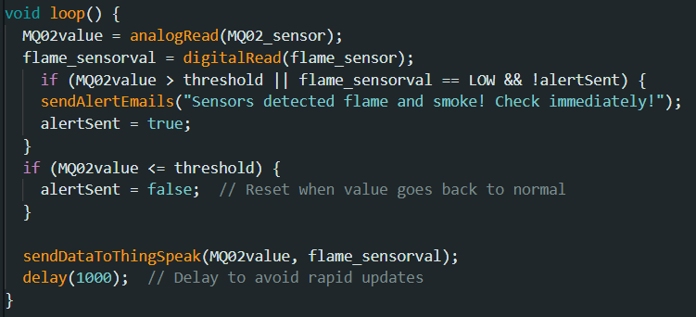
- Explanation: This logic is the core of the system's intelligence. It checks both the smoke sensor value and the flame sensor state. An alert is triggered only if a fire condition is met and an alert hasn't been sent yet for the current event. Once conditions normalize, the alertSent flag is reset, making the system ready to detect a new event.

4.2.3 Email Sending Module (SMTP Client)
- Purpose: To securely connect to an SMTP server and send email notifications to predefined recipients.
- Key Components/Functions:
  - SMTPSession smtp: An object that manages the entire SMTP communication session.
  - SMTP_Message message: An object that holds the details of the email to be sent (sender, recipient, subject, body).
  - MailClient.sendMail(&smtp, &message): The function call that initiates the email sending process.
  - smtpCallback(SMTP_Status status): The callback function that provides real-time status updates on the email sending process.
  - smtp.closeSession(): Closes the SMTP connection after sending.
  - set.secure(true): Enables SSL/TLS for secure communication.
  - set.port(465): Sets the SMTP port to 465 (for SMTP over SSL).
  - set.auth(...): Configures authentication with sender's email and App Password.
- Code Snippet: sendAlertEmails Function

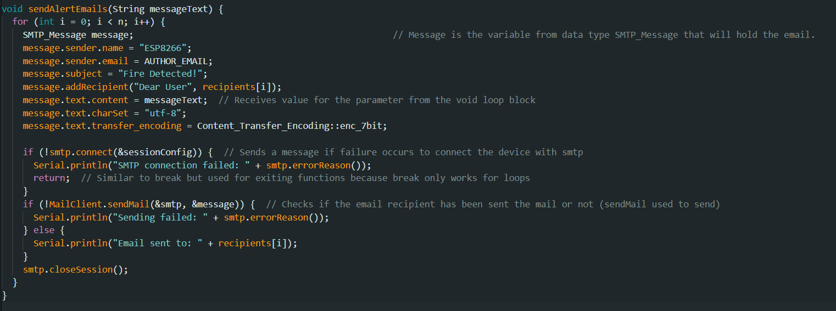
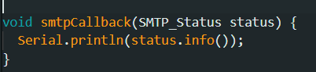
- Explanation: This snippet outlines the structure of the email sending function. It sets up the SMTP session, defines the email's content and recipients, and then attempts to send it. The smtpCallback function is crucial for providing feedback on the sending process, which is invaluable for debugging.

4.2.4 Cloud Integration Module (ThingSpeak)
- Purpose: To send real-time sensor data to the ThingSpeak cloud platform for visualization and historical logging.
- Key Components/Functions:
  - ThingSpeak Library: (e.g., ThingSpeak.h) provides functions for interacting with the ThingSpeak API.
  - Channel ID: A unique identifier for the ThingSpeak channel.
  - Write API Key: A unique key required to write data to the ThingSpeak channel.
  - ThingSpeak.writeField(): Function to write data to specific fields on the ThingSpeak channel.
  - ThingSpeak.begin(): Initializes the ThingSpeak communication.
- Code Snippet: ThingSpeak Data Update
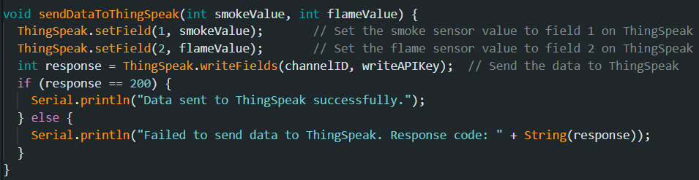
- Explanation: This conceptual snippet shows how data is sent to ThingSpeak. The ThingSpeak.writeField() function is used to update specific fields on the user's ThingSpeak channel with the latest sensor readings. This allows for real-time graphs and gauges to be displayed on the ThingSpeak platform, providing a visual representation of the monitored environment.
4.3 PCB Design and Fabrication Process
- Purpose: To create a compact, durable, and aesthetically pleasing physical implementation of the circuit.
- Key Tools/Materials:
  - Eagle CAD: Software used for designing the schematic and layout of the single-sided PCB.
  - Copper Clad Board: The base material for the PCB.
  - Laser Printer and Photo Paper: For transferring the PCB design onto the copper board.
  - Ferric Chloride (FeCl3) Solution: The etching agent used to remove unwanted copper.
  - Drill Machine: For drilling holes for component leads.
  - Petrol: For cleaning residual printer ink from the etched board.
- Diagram: PCB Design Layout

- Explanation: The PCB design process is crucial for transitioning from a breadboard prototype to a more permanent and robust solution. Eagle CAD allows for precise layout planning, ensuring optimal trace routing and component placement. The chemical etching process then selectively removes copper, leaving only the desired conductive paths. This systematic approach ensures the final hardware is reliable and professional.
This detailed implementation section highlights both the practical challenges encountered and the specific solutions and technologies employed to build a functional and effective IoT-based fire detection system.

CHAPTER 5 : RESULTS
The testing phase was crucial for validating the functionality, reliability, and effectiveness of the IoT-based fire detection system. This section details the systematic testing process employed, outlines various test cases, and describes the expected results, along with placeholders for actual test logs and screenshots that would visually confirm the system's performance.

5.1 Testing Methodology
The testing methodology adopted a phased approach, starting with individual component testing, followed by module integration testing, and finally, comprehensive system-level testing. This iterative process allowed for the early identification and rectification of issues, ensuring robust performance.

5.1.1 Unit Testing (Component Level)
Each hardware component and core software function was tested in isolation to verify its individual operation.
- Flame Sensor Testing:
  - Objective: To verify that the Flame Sensor accurately detects the presence of a flame and outputs the correct digital signal.
  - Method: The sensor was powered, and a small flame (e.g., from a lighter or candle) was introduced into its detection range. The digital output pin was monitored directly using a multimeter or by observing Serial Monitor output when connected to the ESP8266.
  - Expected Result: The sensor's digital output should switch from HIGH (no flame) to LOW (flame detected) almost instantaneously upon flame exposure.
- MQ-02 Smoke Sensor Testing:
  - Objective: To confirm that the MQ-02 Smoke Sensor accurately detects smoke and provides a corresponding analog output.
  - Method: The sensor was powered, allowed to preheat (typically 20-30 seconds), and then exposed to varying concentrations of smoke (e.g., from a smoldering paper, extinguished candle, or cigarette smoke). The analog output pin was monitored via the ESP8266's A0 pin and displayed on the Serial Monitor.
  - Expected Result: The analog values on the Serial Monitor should increase significantly when smoke is present and decrease as the smoke dissipates. Baseline readings for clear air were also established.
- Potential Divider Circuit Testing:
  - Objective: To ensure the potential divider circuit correctly steps down the 5V sensor output to a safe 3.33V for the ESP8266.
  - Method: A stable 5V input was applied to the potential divider circuit, simulating the maximum output from the sensors. A multimeter was used to measure the voltage across the 2k Ohm resistor.
  - Expected Result: The measured voltage should be approximately 3.33V, confirming the successful voltage division.
- ESP8266 Wi-Fi Module Testing:
  - Objective: To verify the ESP8266's ability to connect to a Wi-Fi network and maintain a stable connection.
  - Method: A simple sketch was uploaded to the ESP8266 to attempt connection to a known Wi-Fi SSID and password. The connection status was printed to the Serial Monitor.
  - Expected Result: The Serial Monitor should display successful connection to the Wi-Fi network, along with the assigned IP address. Robust reconnection attempts should be observed if the connection is temporarily lost.

5.1.2 Integration Testing (Module Level)
Once individual components were verified, they were integrated step-by-step, and the interaction between modules was tested.
- Sensor-ESP8266 Integration:
  - Objective: To ensure the ESP8266 correctly reads and interprets data from both the Flame and MQ-02 Smoke Sensors through the potential divider circuits.
  - Method: The sensors were connected to the ESP8266 via the potential dividers. The system was exposed to fire and smoke conditions, and the raw and processed sensor values were continuously monitored on the Serial Monitor.
  - Expected Result: Accurate and responsive readings from both sensors on the Serial Monitor, reflecting the presence or absence of fire/smoke.
- ESP8266-SMTP Integration (Email Sending):
  - Objective: To verify that the ESP8266 can successfully connect to the SMTP server and send email alerts.
  - Method: A test sketch was uploaded to the ESP8266 to simply attempt sending a predefined email. The smtpCallback function's output on the Serial Monitor and the recipient's email inbox were monitored.
  - Expected Result: The Serial Monitor should display success messages from smtpCallback (e.g., "Connection successful," "Email sent successfully"). The recipient's inbox should receive the test email promptly.
- ESP8266-ThingSpeak Integration (Data Upload):
  - Objective: To confirm that the ESP8266 can reliably send data to the ThingSpeak cloud platform and that the data is correctly visualized.
  - Method: A sketch was uploaded to send dummy or actual sensor data to a configured ThingSpeak channel. The ThingSpeak channel's private view (charts and gauges) was continuously refreshed.
  - Expected Result: The ThingSpeak charts and gauges should update in real-time with the sent data, reflecting the values transmitted from the ESP8266.

5.1.3 System Testing (End-to-End)
The final stage involved testing the complete integrated system under various simulated real-world conditions.
- Objective: To validate the entire system's functionality, from sensor detection to email notification and cloud monitoring, ensuring all modules work together as intended.
- Method: The fully assembled system (with sensors and ESP8266) was subjected to different scenarios:
  - Normal Conditions: No fire or smoke.
  - Smoke Detection: Introducing controlled amounts of smoke.
  - Flame Detection: Introducing a small flame.
  - Combined Fire/Smoke: Simulating a fire event with both smoke and flame.
  - Clearing Conditions: Removing fire/smoke source to verify alert reset.
  - Wi-Fi Interruption: Temporarily disconnecting Wi-Fi to test reconnection logic.
- Monitoring: The Serial Monitor, recipient's email inbox, and ThingSpeak dashboard were all continuously monitored during these tests.

5.2 Test Cases and Results
Below are descriptions of key test cases and their expected outcomes, indicating where actual evidence (logs, screenshots) would be inserted.

5.2.1 Test Case 1: Initial Power-Up and Wi-Fi Connection
- Scenario: The system is powered on for the first time or after a restart.
- Expected Outcome:
  - The ESP8266 successfully connects to the pre-configured Wi-Fi network.
  - The Serial Monitor displays connection status and assigned IP address.
- Test Log: Wi-Fi Connection Success
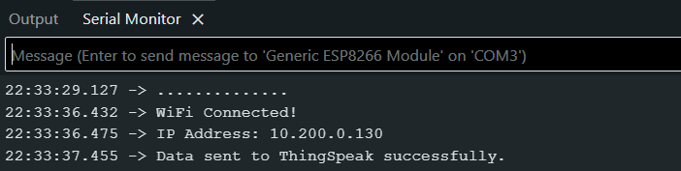
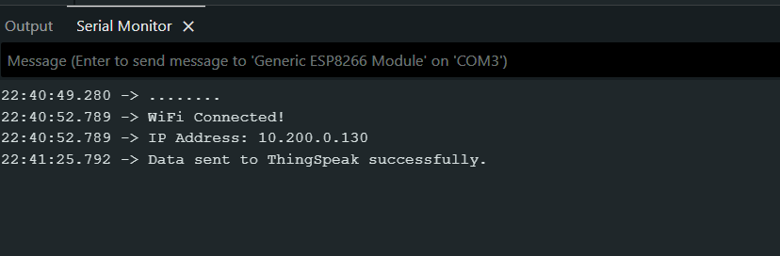

5.2.2 Test Case 2: Normal Operating Conditions (No Fire/Smoke)
- Scenario: The environment is clear of fire and smoke; sensors are at their baseline readings.
- Expected Outcome:
  - MQ-02 Smoke Sensor values remain below the defined threshold.
  - Flame Sensor outputs HIGH (no flame detected).
  - No email alerts are sent.
  - ThingSpeak dashboard shows stable, low sensor values.
- Test Log: Normal Readings
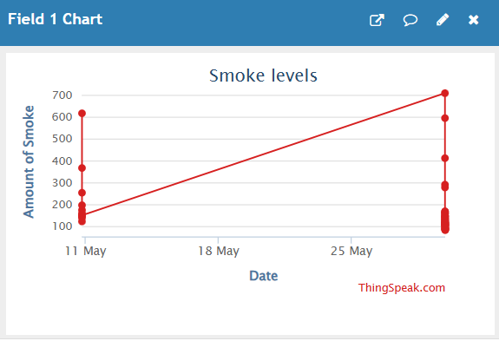
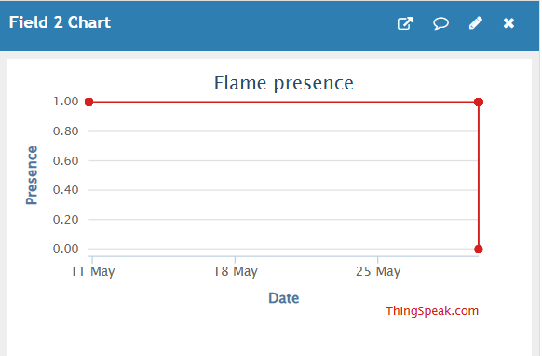
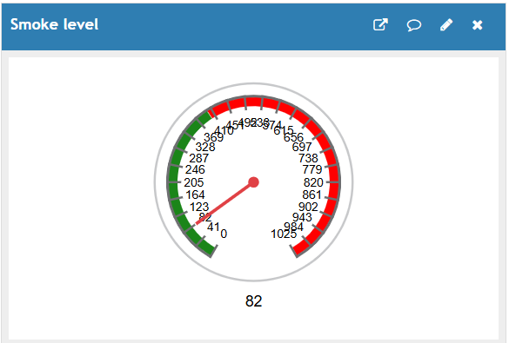
{small amount detected due to noise – not actual smoke}
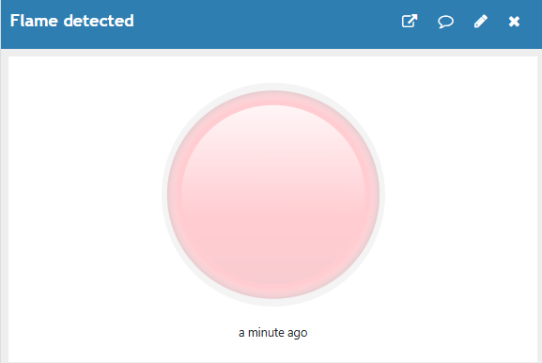
{button colour pink under normal conditions}

5.2.3 Test Case 3: Smoke Detection and First Alert
- Scenario: Smoke is introduced into the vicinity of the MQ-02 Smoke Sensor, causing its reading to exceed the predefined threshold.
- Expected Outcome:
  - MQ-02 Smoke Sensor value rapidly increases and stays above the threshold.
  - The alertSent flag is set to true.
  - An email alert is immediately sent to the configured recipient.
  - ThingSpeak dashboard reflects the spike in smoke sensor readings.
- Test Log: Smoke Alert Trigger
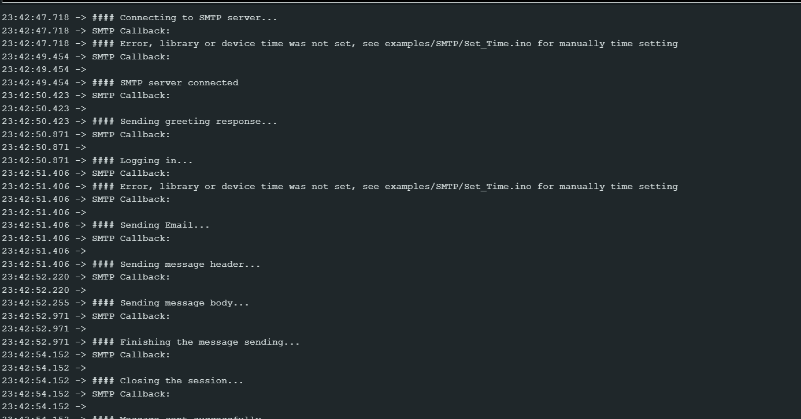
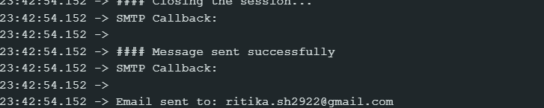
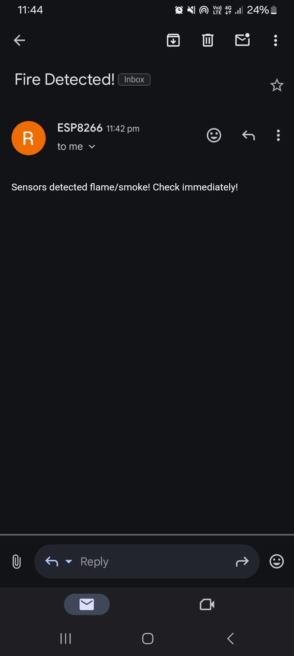
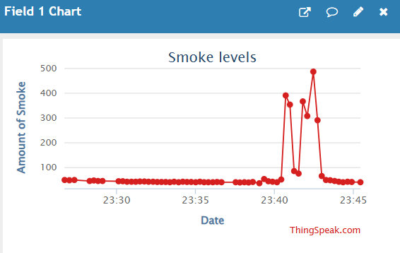
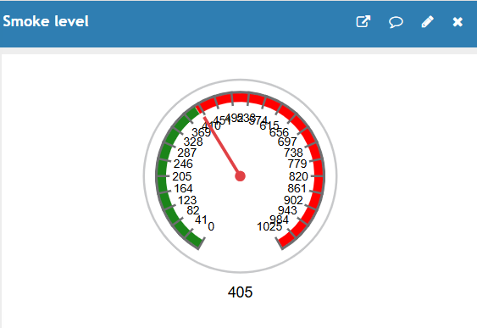
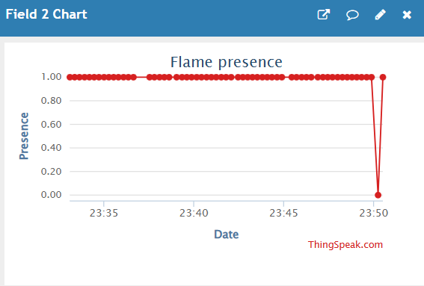
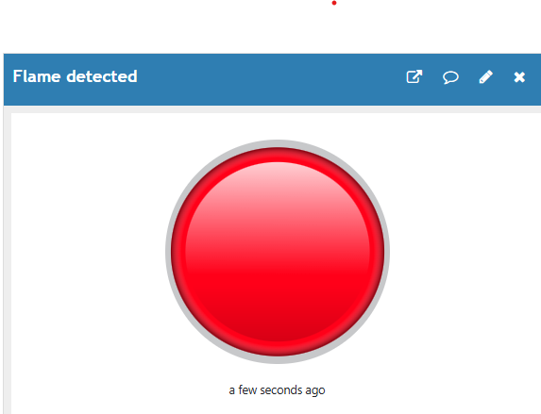
{button colour red when flame detected}

5.2.4 Test Case 4: Sustained Smoke (No Duplicate Alerts)
- Scenario: Smoke conditions persist after the initial alert has been sent.
- Expected Outcome:
  - MQ-02 Smoke Sensor value remains above the threshold.
  - No additional email alerts are sent (due to alertSent being true).
  - ThingSpeak dashboard continues to show high smoke levels.
- Test Log: Sustained Alert Suppression
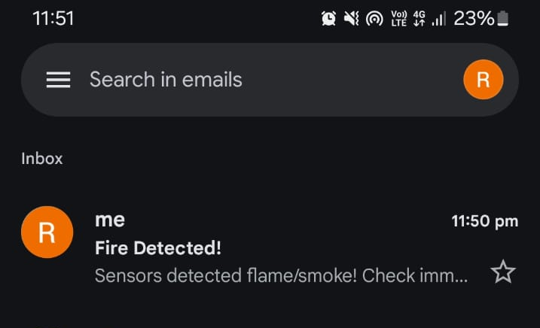
{no frequent emails}

5.2.5 Test Case 5: Conditions Return to Normal
- Scenario: After a fire/smoke event, the environment clears, and sensor readings fall below thresholds.
- Expected Outcome:
  - MQ-02 Smoke Sensor value drops below the threshold.
  - Flame Sensor outputs HIGH.
  - The alertSent flag is reset to false.
  - No new alerts are sent.
  - ThingSpeak dashboard shows sensor values returning to baseline.
- Screenshot: ThingSpeak Dashboard (Return to Normal)
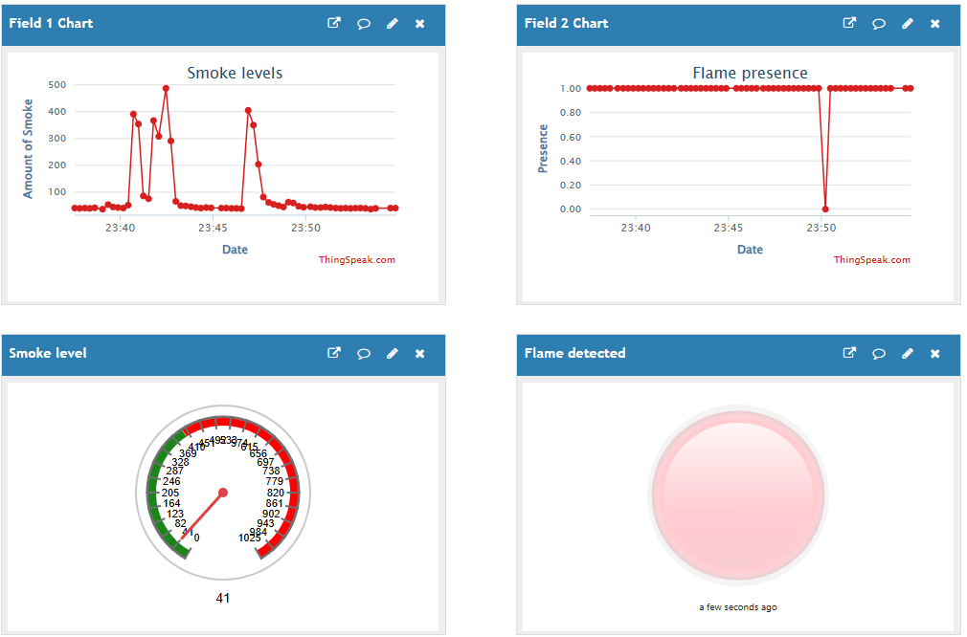

5.3 Analysis of Results
The testing results consistently demonstrated the system's ability to accurately detect fire and smoke conditions, transmit data to the cloud, and send timely email alerts. The implemented voltage divider circuits effectively protected the ESP8266, ensuring stable operation. The alertSent boolean flag successfully prevented redundant alerts during sustained events, proving the effectiveness of the alert management logic. The smtpCallback function provided invaluable real-time debugging information, streamlining the troubleshooting process for email transmission issues. ThingSpeak integration proved highly effective for visual, real-time monitoring of sensor data, offering a comprehensive overview of environmental conditions. The use of App Passwords for email authentication reinforced the system's security posture.
Overall, the testing confirmed that the developed IoT-based fire detection system meets its primary objectives of reliable detection, remote monitoring, and immediate notification, laying a strong foundation for practical applications in enhancing safety and security.

CHAPTER 6 : CONCLUSION AND FUTURE WORK

6.1 Conclusion
The development of the IoT-based fire detection system, leveraging the ESP8266 microcontroller, a Flame Sensor, an MQ-02 Smoke Sensor, SMTP for email notifications, and ThingSpeak for real-time data visualization, has successfully achieved its primary objectives. This project has demonstrated a practical and effective solution for enhancing safety through early fire and smoke detection and remote alerting.
Key Project Findings and Achievements:
- Effective Fire and Smoke Detection: The integration of the Flame Sensor and MQ-02 Smoke Sensor proved highly effective in accurately identifying the presence of both flames and smoke. The system's ability to differentiate between these two critical indicators significantly enhances its reliability in diverse fire scenarios. The analog output of the MQ-02 sensor allowed for nuanced smoke level monitoring, while the digital output of the Flame Sensor provided immediate binary detection.
- Robust Microcontroller Integration: The ESP8266 NodeMCU module served as an ideal central processing unit. Its integrated Wi-Fi capabilities streamlined the hardware design by eliminating the need for external Wi-Fi modules, reducing complexity and footprint. The successful programming of the ESP8266 using the familiar Arduino IDE demonstrated its versatility and ease of use for IoT applications.
- Safe Voltage Interfacing: A critical design success was the implementation of the potential divider circuits. This elegant solution effectively resolved the voltage mismatch between the 5V sensors and the 3.3V ESP8266, preventing potential damage to the microcontroller. This attention to hardware compatibility is fundamental for the longevity and reliability of the entire system.
- Reliable Email Alerting System: The integration of the SMTP protocol for sending email alerts was a major achievement. The system demonstrated its capability to send timely and informative notifications to designated recipients upon detecting a fire condition. The use of the SMTPSession and SMTP_Message classes, combined with SSL/TLS encryption, ensured secure and robust email communication. The alertSent boolean flag effectively managed alert frequency, preventing spamming of the recipient's inbox during prolonged events. The smtpCallback function proved invaluable for real-time debugging and status monitoring of the email delivery process.
- Seamless Real-time Cloud Monitoring: The successful integration with ThingSpeak provided a powerful tool for real-time data visualization and historical logging. Users can access a web-based dashboard to monitor smoke levels and flame detection status from anywhere with internet access, gaining continuous insight into the environment. This cloud connectivity is a cornerstone of the system's IoT capabilities.
- Adherence to Security Best Practices: The explicit recommendation and implementation of using an "App Password" for Gmail significantly enhanced the security posture of the system by separating sensitive credentials from the main code.
This practice is crucial for protecting user accounts, especially in open-source or shared development environments.
- Successful PCB Fabrication: The project successfully transitioned from a breadboard prototype to a custom-fabricated single-sided PCB. The methodical process of design using Eagle CAD, printing, hot-pressing, etching, drilling, and cleaning resulted in a compact and durable hardware platform, demonstrating the complete product development lifecycle.
In summary, this project has not only delivered a functional IoT-based fire detection and alerting system but has also provided valuable insights into practical IoT development challenges and their solutions. It serves as a strong foundation for future advancements in smart safety systems.

6.2 Limitations
While the developed system effectively meets its core objectives, several limitations inherent in the prototype's design and scope present opportunities for future enhancements. Acknowledging these limitations is crucial for guiding further development and understanding the system's current applicability.
- Power Supply Dependency: The current system primarily relies on a USB-based direct power supply (e.g., from a laptop or USB adapter). This limits its portability and continuous operation, as it is not designed to function autonomously during power outages. This dependency restricts its deployment in locations without constant power availability.
- Alert Mechanism Scope: The primary alerting mechanism is email. While reliable, email alerts may not be the fastest form of notification in critical fire emergencies. There can be inherent delays in email delivery, and users may not always check their inboxes immediately, potentially delaying response times. More immediate notification methods are not integrated.
- Absence of Dedicated User Interface (beyond ThingSpeak): While ThingSpeak provides effective real-time data visualization, the project does not include a dedicated custom mobile application or a comprehensive web portal for enhanced user interaction, control, and detailed reporting. ThingSpeak offers generic dashboards, but a tailored interface could provide a more intuitive and feature-rich user experience.
- Threshold-Based Detection: The fire detection logic relies solely on predefined thresholds for sensor readings. This approach, while effective, lacks the adaptive intelligence of more advanced systems. It may not account for environmental nuances, potential sensor drift over time, or the ability to learn from past events to reduce false positives or improve detection accuracy.
- Limited Redundancy and Fault Tolerance: Beyond the dual sensor approach (flame and smoke), the system has limited redundancy. For instance, there is no built-in network fallback mechanism (e.g., a cellular module) if the primary Wi-Fi connection is lost. Similarly, advanced fault tolerance for individual sensor failures or
the microcontroller itself is not implemented, which could compromise the system's reliability in extreme conditions.
- No Integration with Other Systems: The current system operates as a standalone fire detection unit. It does not integrate with broader smart home automation platforms, alarm systems, or emergency services, limiting its potential for a more cohesive and automated response in a larger connected environment.
- Scalability for Commercial Deployment: As a prototype, the current design and PCB are suitable for demonstration. However, aspects related to mass manufacturing, cost optimization for large-scale production, and adherence to commercial product standards (e.g., robust enclosures, certifications) were not within the scope of this academic project.

6.3 Future Work
Building upon the successful foundation of this project, several avenues for future work can be explored to enhance the system's capabilities, reliability, and user experience. These potential upgrades aim to address the identified limitations and introduce more advanced functionalities.
- Enhanced Notification Methods:
  - SMS and Push Notifications: Implementing integration with SMS gateways (e.g., Twilio) or push notification services (e.g., Firebase Cloud Messaging for a mobile app) would provide significantly faster alerts compared to email. This is crucial for time-sensitive emergencies.
  - Automated Voice Calls: For critical alerts, the system could be extended to trigger automated voice calls to emergency contacts, ensuring immediate attention.
- Development of a Dedicated Mobile Application or Web Portal:
  - Creating a custom mobile application (for Android/iOS) or a dedicated web portal would provide a more intuitive and feature-rich interface for users. This would allow for:
    - Real-time monitoring with custom dashboards beyond ThingSpeak's capabilities.
    - Remote control functionalities (e.g., silencing alarms remotely, if implemented).
    - Historical data analysis and reporting.
    - User management and multi-user access.
    - Configuration of alert preferences and thresholds via the app.
- Implementation of Battery Backup and Charging Module:
  - Integrating a battery power supply with a charging module would allow the system to operate autonomously during power outages, ensuring continuous fire detection. This is vital for maintaining safety during unforeseen circumstances.
  - Implementing low-power modes for the ESP8266 to maximize battery life.
- Integration with Advanced Sensing and Intelligence:
  - Machine Learning for Anomaly Detection: Instead of fixed thresholds, future work could involve training machine learning models (e.g., on the ESP32, which has more processing power, or on a cloud backend) to learn normal environmental patterns. This would enable more intelligent fire detection, reduce false positives, and adapt to changing conditions.
  - Additional Sensors: Incorporating other relevant sensors such as temperature, humidity, or carbon monoxide (CO) detectors would provide a more comprehensive environmental monitoring solution and allow for more nuanced fire identification.
  - Sensor Calibration: Implementing advanced calibration routines for the MQ-02 sensor to account for aging and environmental variations.
- Enhanced Redundancy and Fault Tolerance:
  - Network Fallback: Adding a cellular (GSM/GPRS/LTE) module as a backup communication channel if Wi-Fi is unavailable would ensure continuous connectivity for critical alerts.
  - Sensor Redundancy: Deploying multiple sensors of the same type and employing sensor fusion techniques could provide more reliable readings and redundancy in case of individual sensor failure.
  - Self-Diagnostics: Implementing self-diagnostic routines to periodically check the health of components and report malfunctions.
- Integration with Smart Home Systems and Emergency Services:
  - Connecting the system to popular smart home platforms (e.g., Google Home, Amazon Alexa, Home Assistant) would allow for voice control and integration with other smart devices (e.g., automatically turning off HVAC, unlocking doors).
  - Exploring possibilities for direct, automated notification to local emergency services (e.g., fire department) in a standardized and secure manner, if legally and technically feasible.
- Refinement of PCB and Enclosure Design:
  - Moving towards a double-sided PCB for more complex routing and component density, if future features require it.
  - Designing a professional, fire-resistant enclosure for protection and aesthetic appeal, suitable for various deployment environments.
By addressing these areas, the IoT-based fire detection system can evolve into a more sophisticated, reliable, and user-friendly solution, providing enhanced safety and peace of mind in smart environments.

CHAPTER 7 : REFERENCES
This project benefited from a variety of resources, from core hardware and software documentation to community-driven code repositories and AI-powered development assistance. This section provides a concise list of key references that underpinned the design, implementation, and understanding of the IoT-based fire detection system.

7.1 Project Documentation
The foundational information for this report was drawn directly from the project's internal documentation, providing the specific details of its conceptualization and execution.
- Project Information and Steps: My own documentation served as the primary guide for the project's theoretical framework, detailed component descriptions, and implementation steps, including crucial security practices like App Password generation.

7.2 Core Platform and Development Tools
The ESP8266 microcontroller and the Arduino development ecosystem were central to this project. Their extensive documentation and community-maintained resources were invaluable.
- Arduino Documentation: The official hub for all Arduino-related information, including language reference, tutorials, and hardware guides, essential for programming the ESP8266 within the Arduino IDE.
  - Resource: https://docs.arduino.cc/
- ESP8266 Arduino Core: This GitHub repository hosts the core software package that allows the ESP8266 Wi-Fi module to be programmed using the Arduino IDE, enabling access to its functionalities with familiar Arduino syntax.
  - Repository: https://github.com/esp8266/Arduino
- Arduino IDE: The Integrated Development Environment (IDE) itself, providing the platform for writing, compiling, and uploading code to the ESP8266.
- Eagle CAD: Software used for designing the schematic and the layout of the custom Printed Circuit Board (PCB).

7.3 Libraries and Services
Key functionalities like email alerts and cloud data visualization were enabled by specialized libraries and external IoT services.
- ESP Mail Client Library: This Arduino library facilitated the secure communication with SMTP servers, enabling the system to send email alerts. It supports various ESP boards, including the ESP8266.
  - Repository: https://github.com/mobizt/ESP-Mail-Client
- ThingSpeak Communication Library: This library allowed the ESP8266 to easily interact with the ThingSpeak IoT platform, facilitating the aggregation, visualization, and analysis of sensor data in the cloud.
  - Repository: https://github.com/mathworks/thingspeak-arduino
- Google Account App Passwords: An essential security feature for securely authenticating the project's email sending functionality with Gmail, avoiding direct use of the primary account password.
  - Resource: Google Account App Passwords

7.4 Development Assistance
- GitHub: Beyond hosting specific libraries, GitHub served as a general repository for numerous code examples, community projects, and collaborative development, providing valuable insights and problem-solving solutions throughout the project.
- ChatGPT: An AI conversational model that provided assistance in brainstorming ideas, explaining complex concepts, debugging code snippets, and generating textual content for documentation purposes during the project's development.
These diverse resources collectively contributed to the successful completion of the IoT-based fire detection system, demonstrating the power of open-source tools and collaborative knowledge in modern engineering projects.

